MATHEMATICS PAPER 2
2026 CWED MOCK MARKING KEY
- a. $=\frac{x^{2}+x-2}{{(x-1)}^{2}}×\frac{xy-y}{x^{2}+2x}=\frac{(x+2)(x-1)}{\left(x-1\right)(x-1)}×\frac{y(x-1)}{x(x+2)}=\frac{y}{x}$ M1 M1 M1 A1
b.$=\frac{8-3\sqrt{2}}{4+3\sqrt{2}}×\frac{4-3\sqrt{2}}{4-3\sqrt{2}}=\frac{32-24\sqrt{2}-12\sqrt{2}+18}{16-18}=\frac{50-36\sqrt{2}}{-2}=-25+18\sqrt{2}$ M1 M1 M1
$∴ a=-25 and b=18$ A1 A1

- a. $\vec{AB}=\left({2a \atop -3a}\right)-\left({a \atop -2a}\right)=\left({a \atop -2a}\right)=a\left({1 \atop -2}\right)$ M1 M1
$\vec{BC}=\left({μa \atop -7a}\right)-\left({2a \atop -3a}\right)=\left({μa-2a \atop -4a}\right)=a\left({μ-2 \atop -4}\right)=2a\left({\frac{μ-2}{2} \atop -2}\right)=2\vec{AB}$ M1
$∴ \frac{μ-2}{2}=1$ M1
$μ=4$ A1

b. $\log_{3}\left(4x+1\right)-\log_{3}{{(2x)}^{2}=1}$
$\log_{3}{\frac{4x+1}{{4x}^{2}}=1}$ M1
$4x+1={12x}^{2}$ M1
${12x}^{2}-4x-1=0$ M1
$\left(2x-1\right)\left(6x+1\right)=0$ M1
$x=\frac{1}{2}$ A1 as negative solution is rejected

- a. let the terms be $a, a+d, a+2d$ or $a-d, d, a+d$
Sum: $a-d+a+a+d=6$ M1
$3a=6$ M1
$a=2$
Product: $\left(a-d\right)a\left(a+d\right)=-64$ M1
$\left(2-d\right)\left(2\right)\left(2+d\right)=-64$
$8+4d-4d-2d^{2}=-64$
${8-2d}^{2}=-64$
$-2d^{2}=-72$
$d^{2}=36$ M1
$d=\sqrt{36}=6$ M1
Terms are 2, 8, 14 A1

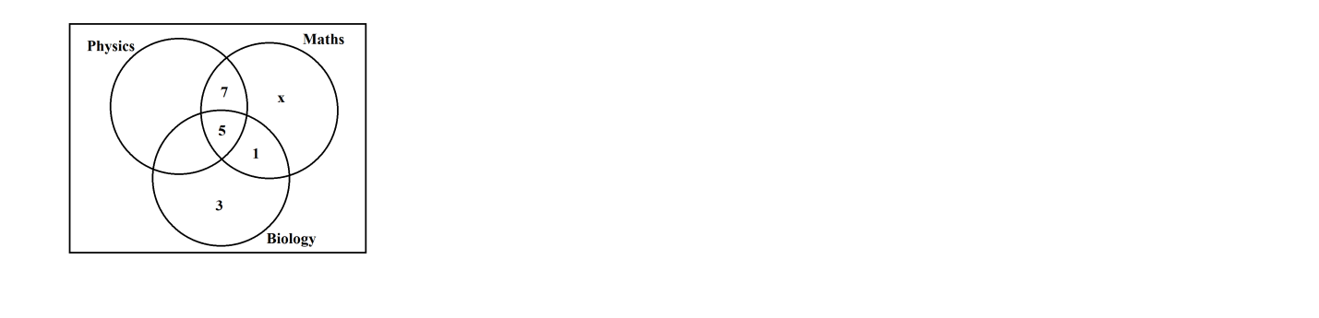
b.

M1 for either 1 or 7
M1 for 3 or x
A1
- a. i. ${AC}^{2}=4^{2}+4^{2}=32$ M1
$AC=\sqrt{32}=4\sqrt{2}$ A1
ii.

$\cos{θ}=\frac{2\sqrt{2}}{4}$ M1
$θ=\cos^{-1}\left(\frac{2\sqrt{2}}{4}\right)={45}^{o}$ M1 A1

b. let x + 2 = 0 x = -2
f(-2) = (- 2)³ – 3(-2) + t = 0 M1
-2 + t = 0
t = 2 M1
using synthetic method
-2 1 0 -3 2
-2 4 -2 M1
1 -2 1 0 M1

f(x) = (x + 2)(x² – 2x + 1) M1
= (x + 2)(x - 1)(x - 1) A1

- a. $y=\left(x+4\right)\left(x-k\right)=x^{2}+\left(4-b\right)x-4k$ M1 M1
$at x= -1 x=-\frac{b}{2a}$
$-1=-\frac{4-k}{2\left(1\right)}$
$-2=-4+k$
$k=2$ M1
$equ y=a(x^{2}+2x-8)$
$-8a=8$ M1
$a=-1$
$∴equ y=-x^{2}-2x+8$ A1
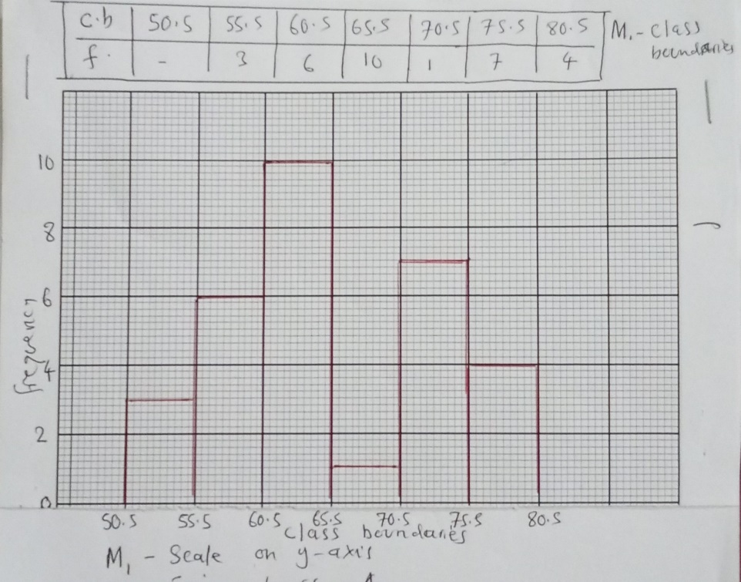
b.

M1 – scale on y – axis
M1 – joining bars
A1

- a. <ABC = 90º AB is diameter M1
<BCD = 90º adja <s
<BCE = < BAC M1
<ABC + <BCE = 90º M1
Also <BCE + <ECD = 90º
<ABC + <BCE + <BCE + <ECD M1
<ABC + <ECD A1
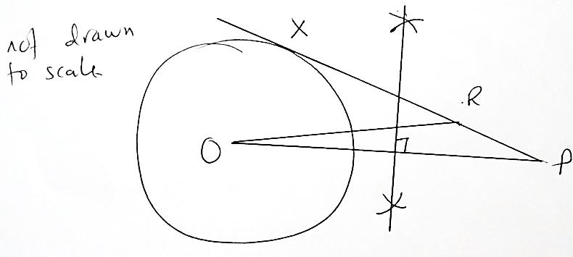
b.

M1 circle
M1 point P
M1 bisection
M1 tangent
A1 correct angle

Section B(40 marks)
- C = k + k₁PD M1
129000 = k + k₁(5)(10) M1 M1
129000 = k + 50k₁ …………..(1)
146000 = k + 84k₁ ……………(2)
Equ (1) – (2) M1
17000 = 34k₁ M1
K₁ = 500
129000 = k + 25000
K = 104000 M1
relationship C = 104000 + 500PD M1
C = 104000 + 500(8)(15) M1
= K164000 M1 A1

- i.
X | -3 | -2 | -1 | 0 | 1 | 2 | 3
Y | -14 | 1 | 4 | 1 | -2 | 1 | 16
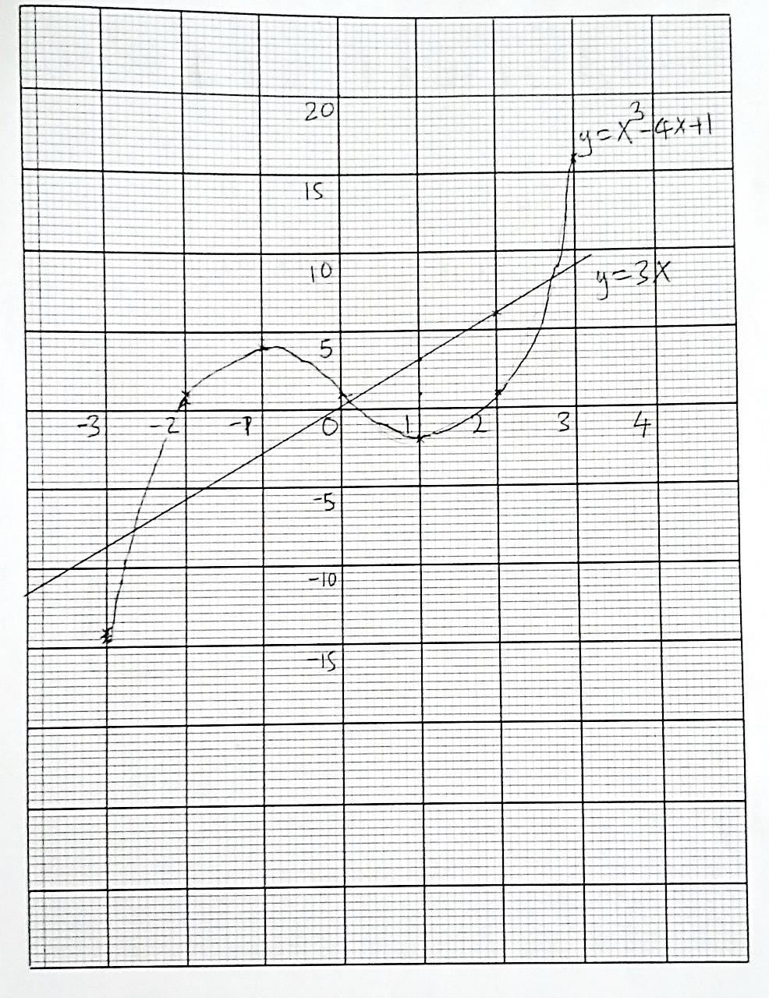
A1
ii.

iii. $y=x^{3}-4x+1-(x^{3}-7x+1)$
$y=3x$ M1
$x=-2.7, 0.2 and 2.5 ±0.1$ A1 A1 A1

- i. $\vec{AB}=\vec{AO}+\vec{OB}=-\underline{a}+\underline{b}$ M1 M1
$AP=\frac{2}{3}\left(\underline{b}-\underline{a}\right)=\frac{2}{3}\underline{b}-\frac{2}{3}\underline{a}$ M1
$\vec{MP}=\frac{1}{2}\underline{a}+\frac{2}{3}\underline{b}-\frac{2}{3}\underline{a}=\frac{1}{6}\underline{a}+\frac{2}{3}\underline{b}$ M1 M1
$\vec{MX}=\frac{1}{2}\underline{a}+2\underline{b}$ M1 A1
ii. $\vec{MP}=\frac{1}{3}\left(\frac{1}{2}\underline{a}+2\underline{b}\right)=\frac{1}{3}\vec{MX}$ M1 M1
$∴\vec{MP}is //to \vec{MX}$ M is common point. Points M, P and X are collinear

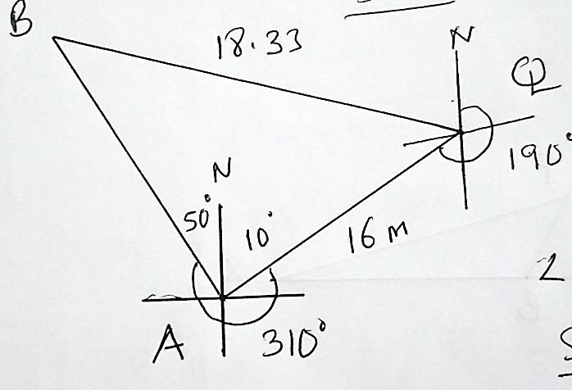

M1 – sketch
<BAQ = 60º M1
$\frac{\sin{θ}}{16}=\frac{\sin{60}}{18.33}$ M1
$\sin{θ}=\frac{\sin{60}×16}{18}$ M1
$θ=\sin^{-1}{(\frac{16\sin{60}}{18})}=49.1$ M1 M1
$<BOA=180-\left(49.1+60\right)=70.9$ M1
$\frac{d}{\sin{70.9}}=\frac{18.33}{\sin{60}}$ M1
$d=\frac{18.33×\sin{70.9}}{\sin{60}}=20m$ A1

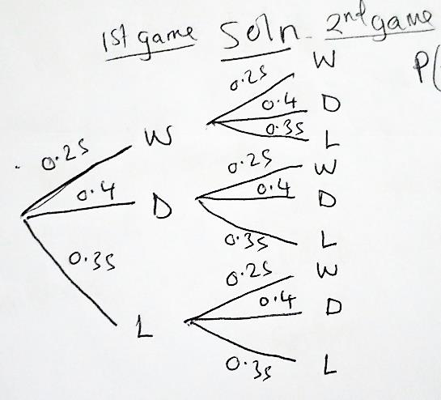
- a.

P(Loosing) = 1 – 0.25 – 0.4 = 0.35 M1 M1 - three outcome branches M1 - one correct path M1 - path for LL
b. P(1W) = P(WD) + P(WL) + P(DW) + P(LW) M1
= (0.25)(0.4) + (0.25)(0.35) + (0.4)(0.25) + (0.35)(.025) M1
= 0.1 + 0.0875 + 0.1 + 0.0875 M1
= 0.375 M1 A1

- a. $x+y≤250$ M1
$10,000x+16000y≥1,600,000$
$5x+8y≥800$
$x≤200$
$x≥\frac{1}{2}y$ M1 last inequality A1
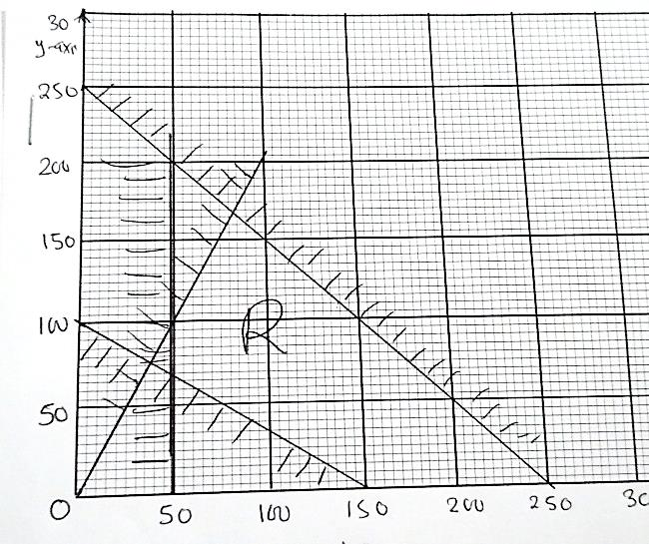
b.

M1 – scale
M1 – Line in single variable
M1 – line in two variables
A1

c. income of tickets = 10000x + 16000y
when y = 140 x = 110
therefore income of tickets = 10000(110) + 16000(140) M1 M1
= K3,340,000 A1

